Powers Farm Signage proposal Aug 5, 2019

To the Randolph Community Preservation Committee –

We would like to propose additional signage at Powers Farm, for the purpose of increasing public access to one of Randolph's best public amenities. I introduced this idea to Town Councilor Arthur Goldstein, who suggested that the Community Preservation Committee would be the appropriate venue to discuss this proposal. Accordingly, We attach a CPA Application for FY20. Could you advise me when is the next Committee meeting, so that we can be present for the CPC review?

See following Action Plan for 9 signage locations, including suggested text of each sign. Available for download at: www.jessegordon.com/Powers_Farm_Signage.doc

See attached PowerPoint presentation for photos of all 9 signage locations. Available for download at: www.jessegordon.com/Powers_Farm_Signage.ppt

See attached map of the geographical locations of all 9 signage locations. Available for download at: www.jessegordon.com/Powers_Farm_Signage.jpg

All of this proposed signage is intended to make Powers Farm more accessible to the public, in particular to newcomers to Randolph who would not otherwise know about these recreational opportunities. The result, I believe, would be greater usage of Powers Farm by pedestrians and bicyclists and cross-country-skiers as an exercising route, or as a central point en route to other recreational resources, or just as a shortcut home. They're all pretty inexpensive – just signs.

Sincerely,

Jesse Gordon
52 West St.
(617) 320-6989
jesse@jessegordon.com

Powers Farm Signage proposal: Action Plan Aug 5, 2019

The letters "A" through "I" indicate points shown on the map below.

- The main entrance to Powers Farm on North Main Street has adequate signage and a welcoming appearance. I believe most residents consider this the ONLY entrance to Powers Farm – the rest of the map indicates how we might better mark the OTHER entrances.

- The Niles Road entrance, in contrast, has a particularly "unwelcoming" appearance. On Niles Road, the abutter has a "No Trespassing" sign – it is on his property, as is his right, but there is no corresponding sign on the public right-of-way indicating where the "No Trespassing" rule terminates. In addition, there is a large and sturdy (and always closed) "car gate" blocking the entire right-of-way. People DO walk around the car-gate, which can be observed by the worn foot-path around it – but there should be a sign indicating "Welcome to Powers Farm." If one gets past the car gate and proceeds up the right-of-way, there is a wire fence that partially blocks the walkway. That wire fence should be replaced with another sign saying "Powers Farm straight ahead; Soule Park and Boardwalk to the right" (two signs and two signposts).

- Turning south from the Niles Road entrance, there is a path along Norroway Pond towards Soule Park on Grove Lane. That path runs very close to several abutters' backyards and would benefit from signage so that pedestrians would know they are not trespassing on private property. The path splits at Soule Park to exit to Grove Lane, or to continue south to the boardwalk – a sign at that point could say "Soule Park / Grove Lane right; Boardwalk straight ahead." At the Grove Lane side of the exit, there is already a sign welcoming visitors to the park. But newcomers would never think to go up Grove Lane to see that sign! (We'll get back to a sign pointing TO the Grove Lane entrance in section H).

- Powers Farm Road has a "right-of-way" entrance to Powers Farm. On the Powers Farm Road side, there are "Private Property" signs posted on what appears to be public property (I suspect the abutters placed those signs to avoid others parking there). The entrance could use a sign saying "Welcome to Powers Farm; Norroway Pond straight ahead". The real issue for this entrance is on the park side….

- The Powers Farm Road entrance leads directly to the "kayak landing" on Norroway Pond. The kayak landing is a wooden deck – lovely for getting into kayaks – but even people using the kayaks don’t realize that there's another way out, just off the south side of the wooden deck. There should be a sign on the kayak landing indicating "Powers Farm Road left; North Main Street straight then right".

- Randall Way seems to be a closed right-of-way – there a steel barrier at the dead-end of Randall Way, with no obvious way to enter the park, and a fence beyond the steel barrier. Inside the park, there is a foot path that dies out before quite reaching Randall Way. Is this a public right-of-way? If so, opening a path through the fence, and adding signage, would initiate foot traffic that would create a footpath. A sign would be appropriate "Welcome to Powers Farm" on the Randall Way side, and "Exit to Randall Way" on the footpath (two signs at two locations).

- The Boardwalk entrance on Grove Street has a welcoming appearance, but no hint of where it actually leads! This is the most common "walking route" for residents in-the-know, but how can newcomers come to know about it? A sign on Grove Street should say "Welcome to the Boardwalk; Powers Farm straight ahead 500 yards." In the other direction, the sign should say "Goldstein Open Space footpath straight; Dog Park right". At the end of the Open Space footpath, there should be a sign, "Boardwalk straight ahead; Dog Park 100 yards to the left" and on the other side "West St, straight 500 yards."

- The Dog Park entrance itself is marked on Grove Street, but there's nothing indicating what's available to people exiting the Dog Park. A sign there should say "Grove Street Park Entrance straight ahead; Boardwalk right".

- There might be one more "central sign" in the middle of the park, indicating what's available in all four directions (or five, if Randall Way is opened). Something like "North 100 yards to woods walkway; east 500 yards to North Main Street; south 500 yards to kayak landing; west 500 yards to Niles Road." I'll count this as two signs, since that's a lot of text for one sign – but perhaps it would be four small signs, all on one signpost, aligned in the proper direction.

* * *
Powers Farm Signage proposal: Action Plan Map Aug 5, 2019

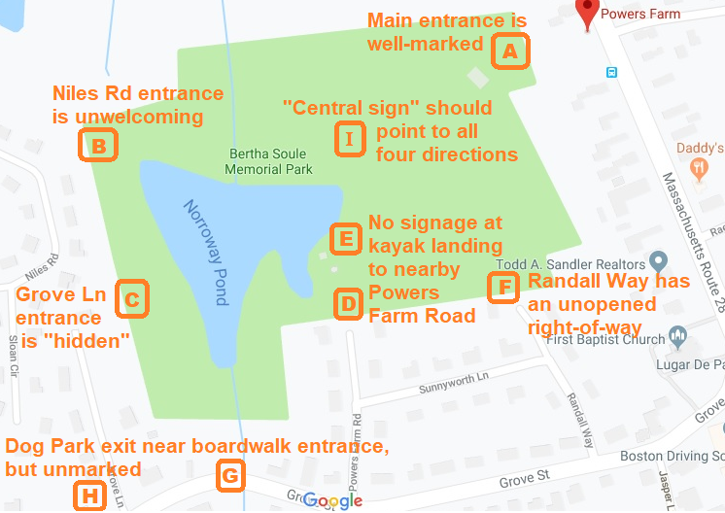

Members:
Ronald Lum, Chair, Housing Authority
Arthur G. Goldstein, Town Council
Bruce Fleischmann, Community Member- Business
Gerald Good Sr., Community Member- Resident
Marcell Robateau, Community Member-Resident
Jim Pasman, Conservation Commission
Mary West, Historical Commission
Alexandra Alexopoulos, Planning Board

