Re: Memo for 2020 House redistricting letter
Aug. 31, 2019

CC: Jason Adams, 13 Emeline St., Randolph
Christos Alexopoulos, 82 Oak St, Randolph
James Burgess, 160 Pond St., Randolph
Natacha Clerger, 580 South Main St., Randolph
Katrina Huff-Larmond, 6 Gloria Rd., Randolph
Paul Meoni, 16 Pine Rd, Randolph
Kerby Roberson, Milton, kerby@robersonlaws.com
Jarred Rose, Stoughton, jarred@jarredrose.com
Denise Swenson, Milton, https://www.townofmilton.org/user/1153/contact

To my fellow residents of 7th Norfolk and 1st Norfolk House districts:

I would like to invite you to sign a joint letter to the state legislature asking that the House redistricting committee create a Randolph-centered House district after the 2020 census. Several of those on this memo's CC list testified after the 2010 census, pointing out the problems with the current trio of House districts that split Randolph, but that testimony was too late in the process to be decisive. My proposed letter is intended to insert Randolph's case into the redistricting process much earlier – and give us a basis to file a lawsuit against the redistricting committee if the post-2020 lines are drawn to split Randolph again.

I have little doubt that, without intervention, the post-2020 House redistricting will split Randolph again, because the focus of the redistricting committee is on Boston. I outline in the section on "12th Suffolk" (Rep. Cullinane) in the letter below how the committee's Boston-focus directly caused the loss of a majority-minority district for the 7th Norfolk district (Rep. Driscoll). I note there that an explicit goal of the post-2010 redistricting was to create MORE majority-minority districts, and they missed one such opportunity in 7th Norfolk.

The relevant excerpt from the "Report from the Chairs of the Special Joint Committee on Redistricting", December 12, 2012: "The Committee increased the electoral opportunities of minority voters living in the Commonwealth in accordance with the principles articulated by the United States Constitution, the Massachusetts Constitution, the Voting Rights Act, and the state and federal courts. ...[T]he Committee did not unduly subordinate traditional redistricting principles for racial considerations, but rather gave due weight to all of the competing legitimate state interests. The Committee created twenty majority-minority House districts, an increase from the prior ten majority-minority districts. "

Regarding the 1st Norfolk district (Rep. Ayers), the existing district is an example of racial gerrymandering which results in the disempowerment of four precincts of Randolph. The Supreme Court's recent rulings on gerrymandering distinguish that partisan gerrymandering is allowed, but racial gerrymandering is disallowed – so I focus on the racial gerrymandering aspects. In the 1st Norfolk district, one-third of Randolph is electorally disempowered by pairing us with a wealthy white section of Quincy, with whom the people of Randolph have little economic interaction nor demographic similarity, based on a misleading geographical closeness.

Randolph is a victim of the state legislature's "packing and cracking." The most majority-minority precincts of Milton are "packed" with Mattapan to the north, instead of with Randolph to the south, resulting in the loss of a majority-minority district in 7th Norfolk. Then Randolph is further "cracked" by splitting up our remaining precincts with Quincy and Braintree, creating a situation where Randolph residents cannot seat our own representative in the Massachusetts House.

The relevant principle of law is summarized from the Supreme Court case Vieth v. Jubelirer, (478 U.S. at 132, 2004): "[U]constitutional discrimination occurs only when the electoral system is arranged in a manner that will consistently degrade a voter’s or a group of voters’ influences on the political process as a whole" (As summarized by NCSL, the National Conference of State Legislatures, in their advice on state redistricting). The "packing and cracking" of Randolph has consistently degraded our political influence in choosing our state Representatives.

The proposed letter below is a draft – subject to your feedback – with the intent of sending it to the four cited House members when complete, and then to the relevant legislative committee. Perhaps some of those four cited members will sign the letter too, which would then be sent to the members of the legislature's Special Joint Committee on Redistricting (who are listed below). Assuming the post-2020 redistricting still splits Randolph, having written in advance would provide a strong basis for a post-redistricting lawsuit.

In looking at other similar lawsuits, the common practice is that past candidates and potential future candidates sign on as co-plaintiffs in the lawsuit. You are one of those past candidates or potential future candidates – are you interested in signing on?

Sincerely,
Jesse Gordon
52 West St. Randolph MA 02368
(617) 320-6989

House Committee on Redistricting
Paul Mark | Chair
Daniel Donahue | Vice chair
Angelo Scaccia | Democratic Member
Colleen Garry | Democratic Member
Sean Garballey | Democratic Member
Frank Moran | Democratic Member
David Rogers | Democratic Member
Jose Tosado | Democratic Member
Dylan Fernandes | Democratic Member
Paul Frost | Republican Member
Steven Howitt | Republican Member
Senate Committee on Redistricting
Cynthia Stone Creem | Chair
Michael Rodrigues | Vice chair
Barbara L'Italien | Democratic Member
James Welch | Democratic Member
Sal DiDomenico | Democratic Member
Bruce Tarr | Republican Member

To: Special Joint Committee on Redistricting
Sep. 15, 2019

Re: Randolph House redistricting

We are writing you regarding the three House districts that include Randolph, and requesting that the upcoming House redistricting create a Randolph-centered House district.

After the 2010 census, Randolph was split into three House districts. The three districts each place precincts of Randolph in the minority of the voting population of the overall district. Randolph's population in the 2020 census will likely exceed 40,000, making Randolph eligible for our own House district. If not a Randolph-only district, then an appropriate House district would include all of Randolph plus one or two neighboring towns' precincts.

Randolph is a majority-minority town, unique among our neighboring towns. Hence splitting up Randolph among our neighboring towns loses the opportunity for a majority-minority House district. In the "Report from the Chairs of the Special Joint Committee on Redistricting", your predecessor committee's report dated December 12, 2012, the committee cited achieving 20 majority-minority districts. We are asking to create a 21st majority-minority district. This letter provides the background and details to do so.

We look forward to working with your committee on this important issue,

Sincerely,

Jesse Gordon
[add others here]
7th Norfolk House district (incumbent Rep. Driscoll)
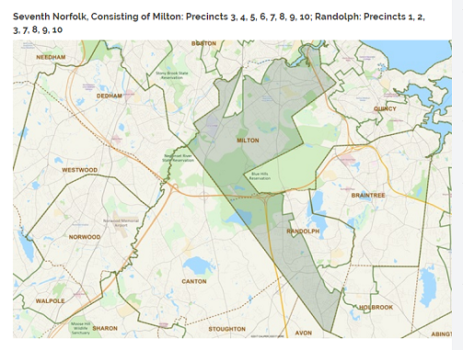
- Milton (population 27,000) is 77% white, and Randolph (population 32,000) is 42% white
- But most of Milton's minority population resides in precinct 1 & 2, which are omitted from the district – those are the areas on Blue Hills Ave south of Mattapan Square. (These two precincts are the "missing slice" at the center north of Milton)
- If Milton precincts 1 & 2 replaced two other (majority-white) Milton precincts, 7th Norfolk would be majority-minority overall.
- From Randolph's perspective, excluding these two precincts is a racial gerrymander. The majority-minority population of Randolph is outvoted by the white population of Milton.
- From Boston's perspective, in the 12th Suffolk district (incumbent Rep. Cullinane) shown below, maintained a majority-minority district for 12th Suffolk, but that could be accomplished with other Boston precincts as well.
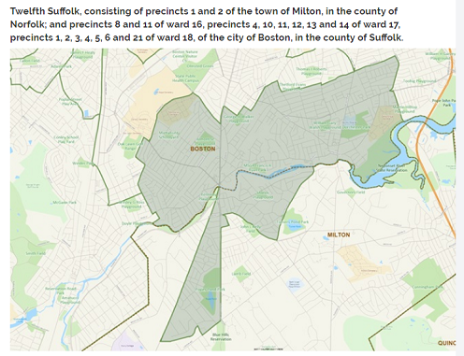
1st Norfolk House district (incumbent Rep. Ayers)
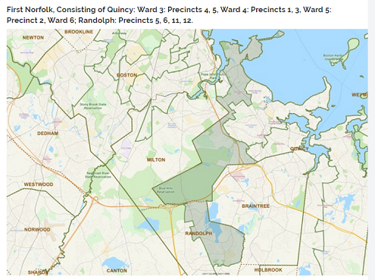
- Quincy (population 92,000) is 65% white, 24% Asian, and 11% other races. Quincy enjoys four state House districts; three of those state Reps are residents of Quincy.
- Quincy's Asian minority population is concentrated in the 2nd Norfolk district. As with the 7th Norfolk district, the precincts merged with Randolph's majority-minority precincts are not the majority-minority precincts of Quincy.
- The neighborhoods of Quincy in this district include Marina Bay and the areas near the President Adams birthplace – some of the highest percentage white populations of Quincy.
- Residents of Marina Bay care about yacht access while residents of Randolph care about MBTA access – there is no demographic nor economic connection between them.
- There is also no meaningful geographic connection – this district is heavily gerrymandered by counting the Blue Hills State Park as if it were a populated area.
- Discounting the unpopulated Blue Hills area, this district is not geographically contiguous, as shown below. This breaches the contiguity principle of redistricting.
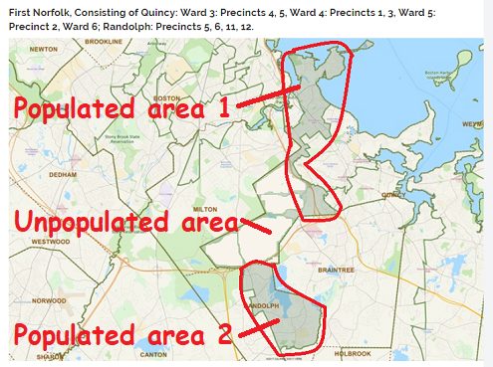
5th Norfolk House district (incumbent Rep. Cusack)
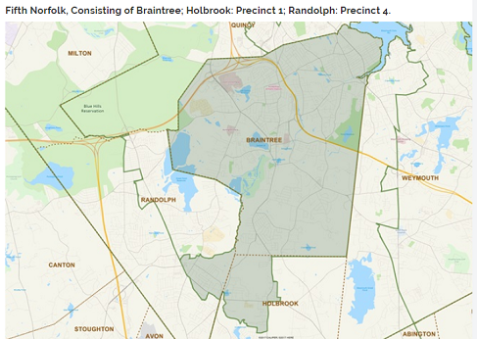
- Braintree (population 35,000) is 94% white; Holbrook (population 11,000) is 92% white.
- Merging one precinct of Holbrook with Braintree is reasonable because they are demographically similar (as is Weymouth to Braintree's east, population 57,000, 84% white).
- The majority-minority population of the Randolph precinct is disempowered in this district, in the same manner as the above two districts, but without any geographic gerrymandering.
- Randolph is unique among its neighbors on the South Shore as the only majority-minority town. Merging any parts of Randolph with its immediate neighbors will disempower our majority-minority population.
- The only solution for avoiding that disempowerment is creating a Randolph-centered House district.

- Randolph had 32,000 people in the 2010 census and may grow to over 35,000 by 2020.
- The population of the average House district after 2010 was just under 41,000 residents; after 2020 the average population should be about 43,100 residents per House district.
- Reasonable additions to a Randolph-centered House district might include :
- Stoughton precinct 1 (approx. population 3,600); it's partly on Randolph's side of Rt. 24
- Avon (approx. population 4,500); its downtown is on the same Main Street as Randolph's
- Holbrook precinct 1 & 4 (approx. population 5,600); formerly "East Randolph" until 1872.
- It is likely that adding any of the neighboring precincts listed above would still result in a majority-minority House district, because Randolph's minority population is growing faster than its overall population (i.e. Randolph will be less than 42% white in the 2020 census).

NOTES:

Special Joint Committee on Redistricting
- Senate order 1/29/2009 and House order 3/5/2009

For 2010-2012 Special Joint Committee:
Senate Chair Stanley Rosenberg of Amherst
Senate Vice-Chair Sonia Chang-Diaz of Boston
House Chair Michael J. Moran of Boston
House Vice-Chair Cheryl Coakley-Rivera of Springfield

From "Report from the Chairs of the Special Joint Committee on Redistricting", December 12, 2012:
"The Committee increased the electoral opportunities of minority voters living in the Commonwealth in accordance with the principles articulated by the United States Constitution, the Massachusetts Constitution, the Voting Rights Act, and the state and federal courts. ...[T]he Committee did not unduly subordinate traditional redistricting principles for racial considerations, but rather gave due weight to all of the competing legitimate state interests. The Committee created twenty majority-minority House districts, an increase from the prior ten majority-minority districts. "

http://www.ncsl.org/research/redistricting/redistricting-and-the-supreme-court-the-most-significant-cases.aspx
[U]constitutional discrimination occurs only when the electoral system is arranged in a manner that will consistently degrade a voter’s or a group of voters’ influences on the political process as a whole.
(Vieth v. Jubelirer, Supreme Court case 2004, and 478 U.S. at 132)
That Supreme Court case and later ones established that partisan gerrymandering is constitutional but racial gerrymandering is not.

In Reynolds v. Sims, the court ruled that "the Equal Protection Clause demands no less than substantially equal state legislative representation for all citizens, of all places as well as of all races."

https://ballotpedia.org/Redistricting_in_Massachusetts_after_the_2020_census#Apportionment_and_release_of_census_data

House Committee on Redistricting membership, 2018
Member Position Political party
Paul Mark Chair Democratic
Daniel Donahue Vice chair Democratic
Angelo Scaccia Member Democratic
Colleen Garry Member Democratic
Sean Garballey Member Democratic
Frank Moran Member Democratic
David Rogers Member Democratic
Jose Tosado Member Democratic
Dylan Fernandes Member Democratic
Paul Frost Member Republican
Steven Howitt Member Republican

Senate Committee on Redistricting membership, 2018
Member Position Political party
Cynthia Stone Creem Chair Democratic
Michael Rodrigues Vice chair Democratic
Barbara L'Italien Member Democratic
James Welch Member Democratic
Sal DiDomenico Member Democratic
Bruce Tarr Member Republican

To the census staff --

I represent a group preparing a lawsuit against the Massachusetts legislature's redistricting committee for racial gerrymandering of the majority-minority city of Randolph after the 2010 census. Our intent is to disseminate in the press the racially-disempowering results of the post-2010 redistricting and how that can be avoided in the post-2020 redistricting. Could you provide a demographic count of each precinct in the following four state House districts?
* 7th Norfolk (Randolph/Milton)
* 12th Suffolk (Milton/Boston)
* 5th Norfolk (Randolph/Holbrook/Braintree)
* 1st Norfolk (Randolph/Quincy)
Searching the internet readily provides the desired demographic information by town, but not by precinct. How might we request precinct-level data for the 2010 census? And how might we request it in advance for the 2020 census?

Sincerely,
Jesse Gordon
52 West St. Randolph MA 02368
(617) 320-6989

