The Town has $20.9 million currently available in COVID relief funds. This document proposes how to allocate that federal funding, with some recommended immediate expenditures and some over the course of the remainder of FY22. Some funding is intended to cover salary expenses through FY23 for new staff.

This document is intended as a framework for discussion at the special Town Council meeting of Jan. 31, 2022. These priorities are only the opinion of Councilor Gordon as a framework for discussion. Other Councilors might present their own priorities as a starting point, as might the Town Manager.

Each item indicates how the proposal is tied to COVID relief. The basic language of ARPA is flexible and generalized: “The American Rescue Plan Act of 2021 provides a substantial infusion of resources to eligible state, local, territorial, and tribal governments to help turn the tide on the pandemic, address its economic fallout, and lay the foundation for a strong and equitable recovery.” Specific page references from Randolph's ARPA consultant report are excerpted and highlighted in brown.

Priority 1: $7.5 million for Drinking Water: ARPA allows funding for “necessary investments in water, sewer, or broadband infrastructure.” Randolph has immediate and long-term needs in this area:

1A. $5 million set aside for the new water treatment plant, to allow zero increase in water bills in FY23.
p. 15, Eligible under Clean Water State Revolving Fund: Construction of publicly owned treatment works
1B. $0.5 million to investigate PFAS sources immediately, and install interim PFAS filters as soon as possible.
p. 15, Eligible under Clean Water State Revolving Fund: nonpoint source pollution management program
1C. $2 million to purchase equipment to replace “dead-end water mains” with looped pipes, to reduce brown water.
p. 15, Eligible under Drinking Water State Revolving Fund: Facilities to improve drinking water quality

Priority 2: $7.5 million for the Hiring Crisis and pandemic recovery: The pandemic has made hiring new staff difficult, and made retaining existing staff challenging too. The Town needs additional new staff to invest in our recovery from the pandemic and our future growth. One-time hiring bonuses (as opposed to salary increases for new positions) can move us past our immediate needs without burdening future years’ budgets. Hiring bonuses to be paid after 6 months on the job. 2D/2E/2F address other pandemic-based crises with one-time spending.

2A. $2 million allocated for advertising and recruiting for the following new Town staff positions: Fire Chief; Assistant Town Manager; Treasurer/Collector; Hiring and Staff Retention Manager; Business Development Officer; three new DPW staff positions (2B above); four new Randolph van drivers (2C above).
p. 13, “Premium Pay” with “higher scrutiny for provision of premium pay to higher earners” [written justification]
2B. $2 million allocated for existing staff to all get comparable retention bonuses at the end of 2022.
p. 13, under Eligible Workers: Any work performed by an employee of a local government [as “Premium Pay”]
2C. $0.5 million for the Randolph Public Schools to assist in the School Committee doing the same for teachers.
p. 12, under Eligible Workers: Educational work [as “Premium Pay”]. This $0.5M would be from the Town; RHS has another $1M available under a new bequest awaiting their allocation.
2D. $1 million for a rent and mortgage relief fund: We passed a resolution on this last year -- Boston does it already.
p. 5, under “Emergency Housing Assistance”: Eligible services include rental arrears and mortgage payment assistance; and p. 4 specialized services for individuals with disabilities or seniors
2E. $1 million for a “Revolving Fund” for loans to small business, to attract new businesses as we wind down from the pandemic; to be administered and publicized by the Business Development Officer in 2A.
p. 8, under “Impact to Small Businesses”: Factors include lost revenue or increased costs
2F. $0.5 million for Resiliency Fund: COVID Benefit Navigator and for a childcare assistance fund
p. 3, under “Assistance to Households”: Uses include: Assistance applying for public benefits or services; programs or services that mitigate impacts childcare and early learning services.
2G. $0.5 million for re-opening RICC and public facilities: Convert community center back from vax site.
2G is not explicitly eligible -- not cited anywhere in Anser report -- but of course converting TO a vaccination and testing site is covered, and I don't think converting back would be an issue.
Priority 3: $1 million for Local Transportation: With more residents working from home during the pandemic, ARPA allows funding “to support the nation’s public transportation systems.”

3A, 3B, 3C seem ineligible despite federal DOT guidance in footnote 5. This must await Infrastructure funding, or in the "$10 million eligible for replacement of lost municipal tax revenue," which disallows only applying funds to tax cute, pensions, or debt payoff.
3A. $2 million to purchase equipment and fund several full street repaving projects, to increase our repaving rate.
3B. $0.5 million to hire three new DPW staff for pothole repair and other work; to fund new salary through FY23.
3C. $1.5 million to purchase vans and establish “Randolph Shuttle” routes to nearby transportation hubs (map below).
3D. $1 million to immediately add traffic features -- sidewalks and traffic lights -- planned in early Traffic Study phases.
p. 7, under “Investments in Neighborhoods”: eligible uses such as sidewalks and streetlights.

Priority 4: $1 million for Outdoor Recreation: The Randolph Master Plan calls for better pedestrian access to parks; the pandemic makes improved outdoor recreation a necessity and also addresses mobility access as outlined in the Randolph Community Wellness Plan.

4A. $0.5 million for a series of boardwalks (like at Powers Farm) for pedestrian access across swampy areas, allowing residents to walk to work or walk to nearby transit lines. For example, a boardwalk across the Great Bear Swamp would connect the Bittersweet apartments to the Patten Drive business area -- red dashed lines on map below.
p. 7, under “Investments in Neighborhoods”: eligible uses such as parks, green spaces, and pedestrian safety features
4B. $0.5 million for a series of parking places at existing parks that have limited pedestrian access, to replace “No Parking” and “No Dumping” signs. For example, where can one park to enter the South Randolph Conservation Area?
p. 7, under “Investments in Neighborhoods”: eligible uses such as projects to revitalize public spaces

Summary with eligibility notes:

Priority 1: $7.5 million for Drinking Water: all eligible

Priority 2: $7.5 million for the Hiring Crisis and pandemic recovery: all eligible with some written justification required for Premium Pay to higher earners in town government.

Priority 3: $4 million for Local Transportation: Street repaving and Randolph Shuttle are ineligible
Priority 3D. $1 million: Sidewalk and streetlight projects are eligible

Priority 4: $1 million for Outdoor Recreation: all eligible

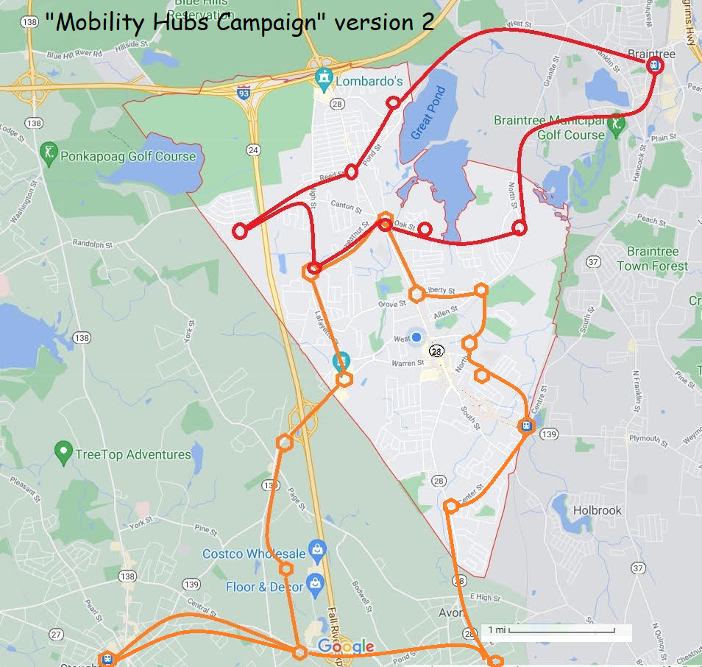

Randolph Red Route:  - Avalon (Prynne Hills) housing complex;  - Middle School going east;  - Reed Street housing complex;  - Pacella Park housing complex;  - Braintree Station and connection to MBTA and connection to #236 bus;  - Meadow Lane housing complex and connection to #238 bus;  - Francis Crossing housing complex and connection to #240 bus;  - Rosemont Square housing complex;  - Middle School going west;  - Irving Road housing complex;  - return to Avalon (loop). |  | Randolph Orange Route:  - Randolph/Holbrook commuter rail station;  - Elderly Drive senior housing;  - RICC / Decelle senior housing;  - Liberty Place housing complex;  - Grove & Main and connection to #238 bus;  - Francis Crossing housing complex and connection to #240 bus;  - Rosemont Square housing complex;  - Mazzeo Drive shopping area;  - Target shopping area;  - Ikea shopping area;  - Home Depot shopping area;  - Stoughton commuter rail station  - Return to Harrison Ave and cross Rt 24  - Harrison Ave thru Avon Center to WalMart  - South Main Street at Center Street  - Return to commuter rail station (loop)

Reducing PFAS in Drinking Water with Treatment Technologies
Published August 23, 2018 (EPA) -- excerpts…
EPA researchers have been studying a variety of technologies at bench-, pilot-, and full-scale levels to determine which methods work best to remove PFAS from drinking water….

Granulated Activated Carbon (GAC)
Activated carbon treatment is the most studied treatment for PFAS removal. Activated carbon is commonly used to adsorb natural organic compounds, taste and odor compounds, and synthetic organic chemicals in drinking water treatment systems. Adsorption is both the physical and chemical process of accumulating a substance, such as PFAS, at the interface between liquid and solids phases. Activated carbon is an effective adsorbent because it is a highly porous material and provides a large surface area to which contaminants may adsorb. Activated carbon (GAC) is made from organic materials with high carbon contents such as wood, lignite, and coal; and is often used in granular form called granular activated carbon (GAC).
GAC has been shown to effectively remove PFAS from drinking water when it is used in a flow through filter mode after particulates have already been removed. EPA researcher Thomas Speth says, “GAC can be 100 percent effective for a period of time, depending on the type of carbon used, the depth of the bed of carbon, flow rate of the water, the specific PFAS you need to remove, temperature, and the degree and type of organic matter as well as other contaminants, or constituents, in the water.”
For example, GAC works well on longer-chain PFAS like PFOA and PFOS, but shorter chain PFAS like Perfluorobutanesulfonic acid (PFBS) and Perfluorobutyrate (PFBA) do not adsorb as well.
Powdered Activated Carbon (PAC)
Another type of activated carbon treatment is powdered activated carbon (PAC) which is the same material as GAC, but it is smaller in size, powder like. Because of the small particle size, PAC cannot be used in a flow through bed, but can be added directly to the water and then removed with the other natural particulates in the clarification stage (conventional water treatment or low-pressure membranes - microfiltration or ultrafiltration). Used in this way, PAC is not as efficient or economical as GAC at removing PFAS. Speth says, “Even at very high PAC doses with the very best carbon, it is unlikely to remove a high percentage PFAS; however, it can be used for modest percent removals. If used, however, there is an additional problem with what to do with the sludge that contains adsorbed PFAS.”

Jesse Gordon notes: The best PFAS water treatment is "reverse osmosis," which we will install with our new water treatment in a couple of years. That method is detailed in the EPA article, but is not available in the current Randolph/Holbrook water treatment plant due to space considerations. So at issue is, "What do we do for the interim years?" The GAC and PAC methods can reduce PFAS in the interim period -- not perfect, but quick.
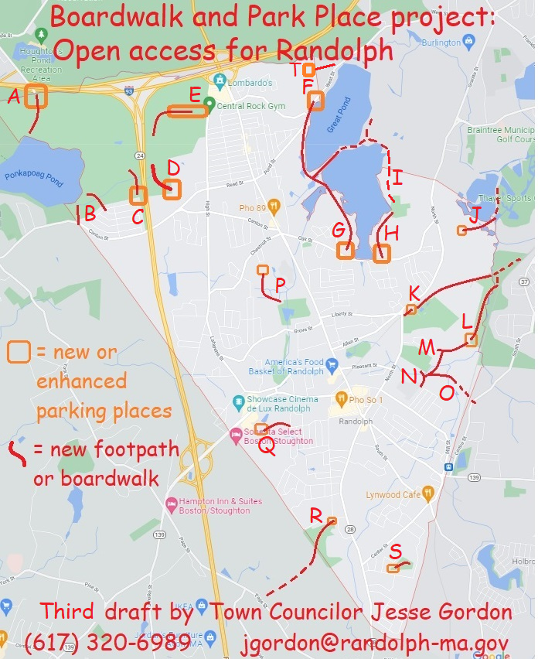

Description of each proposed Boardwalk and/or Parking Place:
- Exit 3 on Interstate 93: Already a parking area here; I proposed to DCR to expand it as part of Ponkapoag Pond project and they likely will do so. The Town could add our own signage linking to other Randolph access points.
- The Town has several "right-of-way" access points into the Blue Hills State Park (town land off Sunset Drive). I proposed to DCR opening these for pedestrians -- it's our responsibility on the Town side.
- At the end of Turner Drive is a right-of-way that leads directly to a DCR hiking trail. We could add signs and a path to that hiking trail, and create a few parking spots. I proposed this to DCR too, but it's unlikely they'll participate.
- The Donovan School has a hiking trail entrance at the back of the parking lot (off of Reed Street). There's a sign on Reed Street but none in the parking lot -- we could define parking rules and add signs.
- There's a street called "Middle Street" off High Street, which is closed by DCR with a gate. The street extends several hundred yards to the abandoned missile site but also to several hiking trails. The entire street could be opened as a parking area.
- The north end of the Reservoir Walk (off Pond Street) has a few parking spots, but needs signs so people know that it's legal. And some signs indicating hiking destinations (including a hidden workout area near this spot!)
- There's another workout area off of Oak Street that has no parking. Let's add a few spots so people can use this, It also leads to a the same Reservoir Walk trail, but needs signs because it's hidden.
- Off Oak Street on the east side of the reservoir is another section of the Reservoir Walk, with some parking spots that look like they're illegal. Needs signs saying what's legal and encouraging hiking.
- The Fin-Fur-Feather conservation area is hidden in the woods -- it needs signage welcoming in pedestrians, including hidden entrances on Isabell Circle and State Street. I've discussed with Braintree residents and representatives continuing the Reservoir Walk on their side -- it's very rough but you CAN walk around!
- The Richardi Reservoir spans the Randolph-Braintree border like the main reservoir does -- and it could also have a Reservoir Walk. Possible entry points include Meadow Lane, Lincoln Ave, and Randolph Road -- some right-of-way's already exist.
- There's a "rail trail" that extends from Depot Street to North Street and then peters out east of North Street. But the rail trail is there -- we just have to clear it and put up some signs. It even has a parking area on the east side of North St near Liberty Street. This rail-trail leads into Braintree and could connect directly to the MBTA station.
- At the back of Teed Drive and Chief's Way (at the FedEx building) is a very large swampy area called the "South Street Conservation Area" which extends into Braintree and Holbrook. We could make parking spots on Chief's Way, and make boardwalks through the swampy areas to connect to several points.
- Possible entry points include: Cochato Park/Roycroft Drive, Kingcrest Terrace, and Seton Way (St Mary's school). Boardwalks across the Conservation Area would provide pedestrian access from several neighborhoods to the MBTA #230 bus, which runs from Braintree to Holbrook just east of the Conservation Area.
- The JFK Elementary School property abuts this same swampy area and could be connected by a boardwalk.
- There is a bridge over the railroad tracks from Randolph to Holbrook -- a street called Kelleway Drive which currently has access only from Holbrook. Making a boardwalk connection to Kelleway Drive would allow pedestrian access to the Commuter Rail station, and a bicycle route to the Braintree MBTA station.
- The Town of Randolph recently acquired a new parcel of Powers Farm abutting Niles Road. A boardwalk through the swampy area could provide pedestrian access via Chestnut Circle. A new parking area accessible from Chestnut Circle could provide much-needed overflow parking for Powers Farm events.
- The south end of Thomas Patten Drive (past the post office) abuts a swampy area that could have a boardwalk of only a couple hundred yards length, to Bittersweet Lane. A small parking area could provide an entry point with signs. The boardwalk would allow pedestrian access from the nearby apartment complexes to the many workplaces on the other side: the hotels; the theater; and so on -- reducing traffic for employees and customers.
- The Lokitis Conservation Area abuts Stoughton Street and L'Heireux Circle but has no marked entrances. A few parking spots on Stoughton Street, and a sign, would allow access through the Conservation Area to Avon -- it's actually walkable distance to D. W. Field! It's the Avon Industrial Park on the other side -- we'd need to work with Avon to put up some signs.
- The South Randolph Conservation Area abuts North Sherwood Ave., north Richmond Ave., and North Glenway Ave -- but has no visible access points. Creating a few parking spots and a hiking trail or boardwalk would allow recreational usage instead of just a lot of "No Dumping" signs. The Randolph Master Plan recommends pedestrian-accessible parks in South Randolph -- this could be one, right away!
- Connecting Pacella Park Drive with the old Rt 128 paved hiking trail in Braintree

“American Rescue Plan Act of 2021,” by Granicus GovQA, https://www.govqa.com/arpa-american-rescue-plan-act/
“Final Rule Summary: ARPA,” by ANSER Advisory, released Jan. 25, 2022, available at http://www.jessegordon.com/ARPA_Anser.pdf
“Using American Rescue Plan Act Funds for Water, Wastewater and Stormwater Infrastructure Projects,” by C Berndt & C. Koch, National League of Cities, June 2021, https://www.nlc.org/article/2021/06/01/using-american-rescue-plan-act-funds-for-water-wastewater-and-stormwater-infrastructure-projects/
“Reducing PFAS in Drinking Water with Treatment Technologies,” by United States Environmental Protection Agency, Aug. 23, 2018, https://www.epa.gov/sciencematters/reducing-pfas-drinking-water-treatment-technologies -- see excerpts below
“American Rescue Plan Act of 2021,” by the Federal Transit Administration, United States Department of Transportation, https://www.transit.dot.gov/funding/american-rescue-plan-act-2021

