Let’s get November’s ballot printed in Haitian Creole!
On the November 2022 ballot, I was thrilled to see our state election ballots printed in Vietnamese as well as the usual English. But I wondered, “Randolph has more Haitian Creole speakers than Vietnamese speakers, so why did the ballots get printed only in Vietnamese?” So we made a plan to fix that! Here’s how....
We called the Secretary of State’s office (and then several more government agencies!) to figure out the rules. There’s a federal law that requires printing the ballot in foreign languages if more than 5% of your city’s population speaks one foreign language at home. That 5% is determined by the 2020 census, and took effect across Massachusetts and nationwide in 2022. But the only languages that qualify are Spanish, Asian languages (except Arabic), and Native American languages. That means “yes for Vietnamese but no for Haitian Creole.”
Could that list of languages be changed? Only by federal legislation (“an Act of Congress”). But we CAN change it at the state/municipal level instead of federally. That’s called a “Home Rule Petition,” which means an exception to state law for one municipality. That whole process is described here, and the final version of our “Home Rule Petition” appears on the other side –
we’ll need YOUR help to make this happen! Some details:
Randolph is the only city in Massachusetts that qualified for Vietnamese-language ballots. Other municipalities do qualify for Spanish and other languages, but only Randolph qualified for Vietnamese-language ballots. Randolph can be proud of serving our Vietnamese-speaking neighbors’ election needs well, and now we should work towards serving our Haitian Creole-speaking neighbors too!  The federal legislation that specifies that list of languages is Section 203 of the Voting Rights Act, which targets “language minorities [who] have been effectively excluded from participation in the electoral process.” Haitian Creole-speakers have not been “effectively excluded,” according to our federal government, so there’s no requirement to print Haitian Creole ballots even though Randolph has well over 5% of Haitian Creole speakers.  Because printing Randolph’s ballots in Vietnamese is a federal requirement, the Secretary of State’s office pays for translating and printing our ballots. They’ll do the same for Haitian Creole, for state and federal elections, but not for municipal elections. That means printing the November 2025 municipal ballots are up to the Town of Randolph to fund, but all the other ballots in 2024 through 2025 are paid for by state funds. |  | 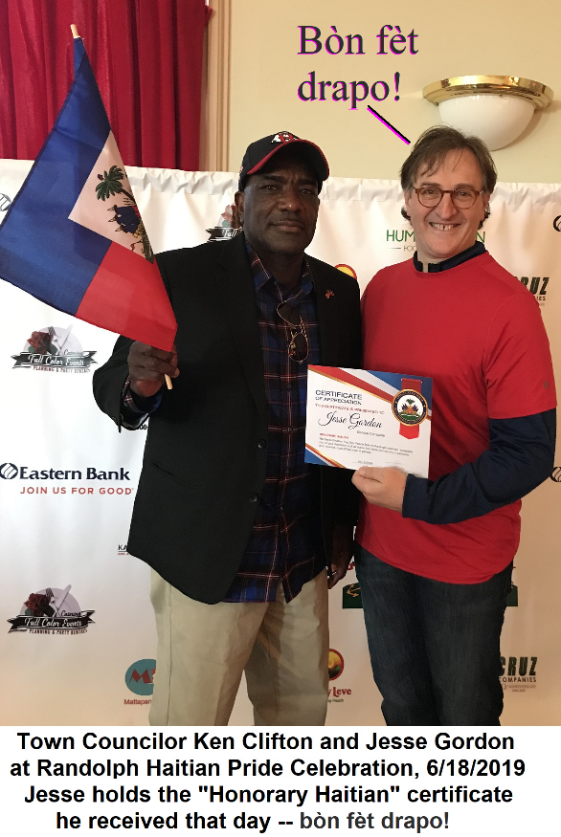
The Town of Randolph also has to pay an election worker at each polling place who can assist with the Haitian Creole ballots (i.e. a translator). That same rule applies to our Vietnamese ballots, and Randolph hired Vietnamese-speaking election workers in four polling places in November 2022. Because Randolph has more Haitian Creole speakers than Vietnamese speakers, it will likely be easier to find election workers in that language. Si w pale kreyòl ayisyen, ou ka sèvi kòm volontè!
Randolph is one of 5 municipalities in Massachusetts with a significant Haitian Creole community. The other 4 are Medford, Somerville, Brockton, and Boston. So we contacted all 4 of those City Councils, to see if they would pass a similar Home Rule Petition. Getting several municipalities to ask for the same Home Rule Petition makes the state legislature much more likely to pass the legislation quickly. If you have friends or family in those other 4 cities, ask them to bring this issue to their City Council!
Once the Home Rule petitions get to the legislature, we rely on our State Reps and State Senators to bring the bill to a vote, and to get their colleagues to vote Yes. Contacting your state legislator helps a lot – just to let them know that you’d like them to pass this legislation – it’s called “Bill HD.4474”. Former State Senate candidate Kathleen Crogan-Camara will lead the effort to contact our state legislators – contact info on other side!
Town Councilors Jesse Gordon and Katrina Huff-Larmond introduced this Home Rule Petition to the Randolph Town Council, and are committed to seeing it through to implementation.
Sincerely,  Jesse Gordon, (617) 320-6989, jesse@JesseGordon.com |   JesseGordon.com/creole.htm |   Enfòmasyon an kreyòl ayisyen
